Royal Cornwall Hospitals NHS Trust Dermatology Unit

**Comfifast Garments – Patient information and instructions for use**

* Non-drug intervention for helping to treat atopic eczema
* Simple, safe and easy to use
* Made of a light and breathable fabric that is suitable for machine washing at 60 degrees
* Stay soft fabric to ensure softness even after repeated washing
* Unobtrusive, discreet and comfortable to wear under clothing or school uniform
* Provide an effective skin covering when using steroid and emollient creams and ointments, enhancing their penetration and effectiveness
* Creates a barrier against scratching
* Prevents the transfer of cream and ointment onto bedding and clothing

**How to Apply**

Garments are put on in a particular way to help prevent itching; and displacing cream / ointment so not pushed into hair follicles and skin cracks

* Turn the garment inside out (seams on the outside)
* Roll the arms and legs up
* Put the garment on trying not to drag cream/ ointment along the skin
* When in place roll the arm and legs down the limb
* Baby tights can be applied by stretching the fabric out to avoid displacing the cream / ointment
* If the neck of the vest is too tight cut a vertical slit in fabric to make it easier to put on
* Garments are snug so do not use with additional nightwear or warm bed coverings as your child may get too hot

Simple, safe and easy to use

• U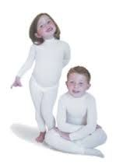no[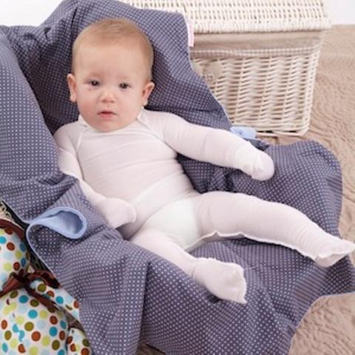](https://cdn.shopify.com/s/files/1/1675/8255/products/Comfifast_Easywrap_Vest_Fold_Mitts_Baby_1024x1024.jpg?v=1571439059)e w clothing

• Creates a barrier to scratching, with seams on the outside

How to • Helps support